**Full Stack**

**NAME : Aishwarya Basavaraj Kotabagi**

**USN : 01FE20MCA005**

**Collection Name : books**

**INSERTING DATA INTO COLLECTION : books**

**Document1:**

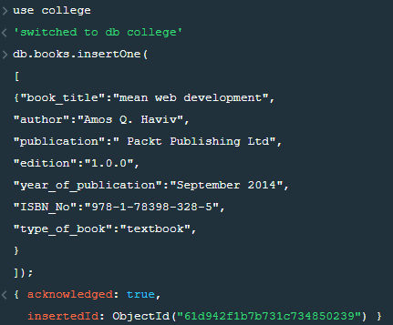

**Document2:**

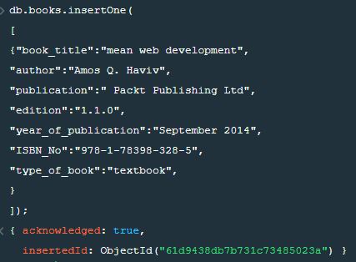**Document3:**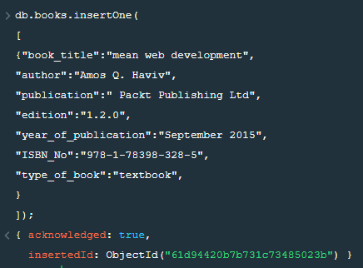

**Document4:**

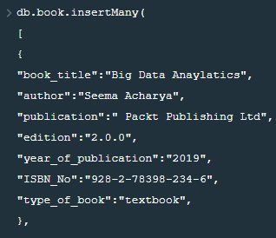

**Document5:**

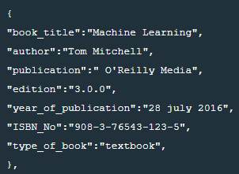

**Document6 & Document 7:**

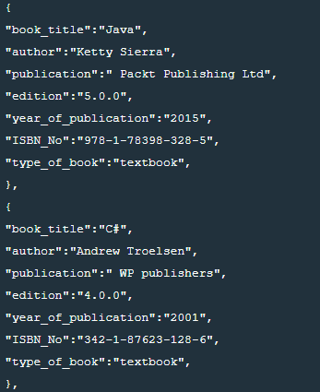

**Document 8 & Document 9:**

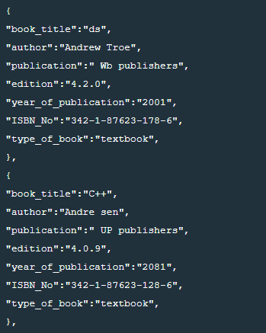

**Document 10 & Document 11: 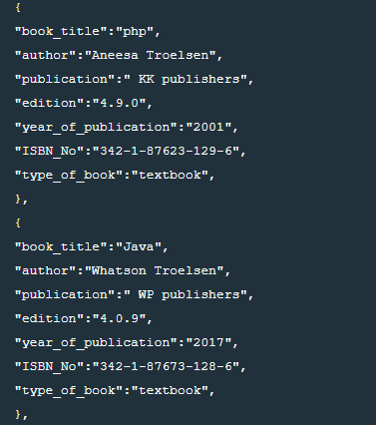Document 12:** 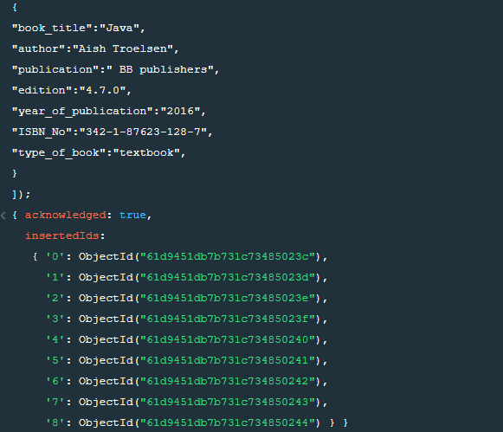

**Display the documents of collection BOOKS :**

**Db.BOOKS.find()**

**To Update :**

db.books.updateOne({"book_title":"php"},{$set:{edition :"4"}});

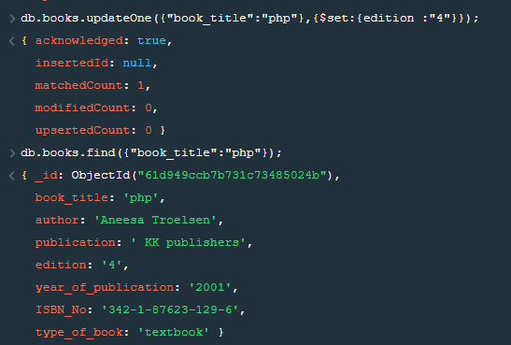

**Delete Operation :**

db.books.deleteOne({"author":"Aneesa Troelsen"});

**Delete.png**

**Queries**

**1 Retrieve the books which contains the title as java(case in-sensitive)**

db.books.find({"book_title" : { '$regex':/^Java$/i}});

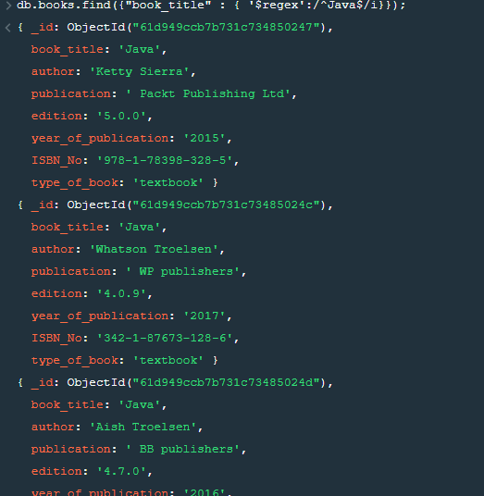

**2. Retrieve the books which contains the title as java and year of publication is greater than 2015**

db.books.find({"book_title":"Java",Year_of_pub:{$gt:2015}});

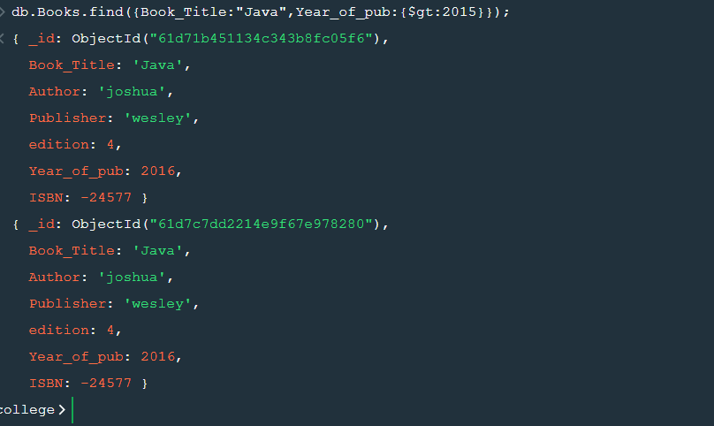

**3. Retrieve the name of the author who has published more than two books.**

**4.Retrieve the books whose edition is between 3rd and 4th**

db.books.find({edition:{$gte:3,$lte:4}});

